**Assignment – 4**

**Name: Chethan Kacham**

**Username: CXK34890**

**Student ID: 700743489**

I have added all the code and commented the tasks as a heading in the code which are given to that specific question.

**Question – 1:**

Adding the screenshots of the code and output for Question -1

Code:

Output:

**Question – 2:**

Adding the screenshots of the code and output for Question -2

Code:

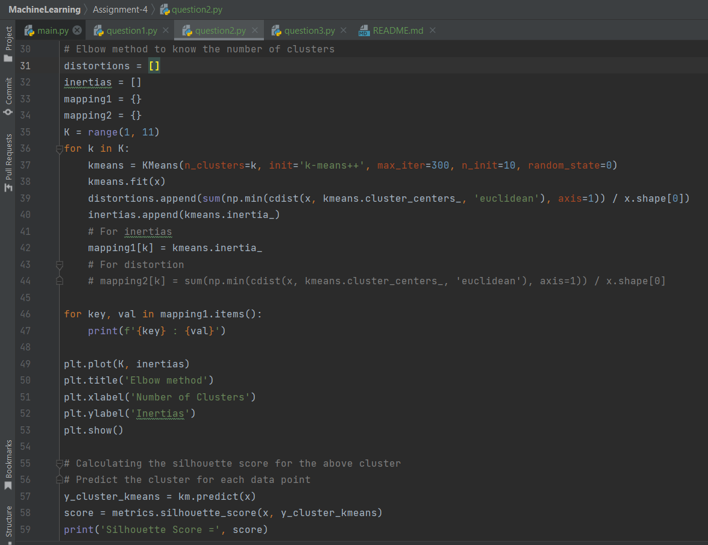

Output:

**Question – 3:**

Adding the screenshots of the code and output for Question -3

Code:

Output:

In GitHub Machine Learning repository, we have an Assignment 4 folder where I have uploaded code, screenshots, word document. Uploaded code of all questions in one single file main.py and separate files for each question named as question1.py, question2.py and question3.py. The following is the link of the GitHub repository

**GitHub link:** <https://github.com/ChethanKacham/MachineLearning.git>

**Video link:** <https://youtu.be/Y6x-uV8CulE>